 | ALL SAINTS CATHOLIC SCHOOL  BRICK FUNDRAISER  575-627-5744  Support All Saints Catholic School Roswell by purchasing a personalized brick that will be a permanent feature on our campus for future generations. This is a tax-free donation.  Prices are for 2026 only | View this in front of the school.  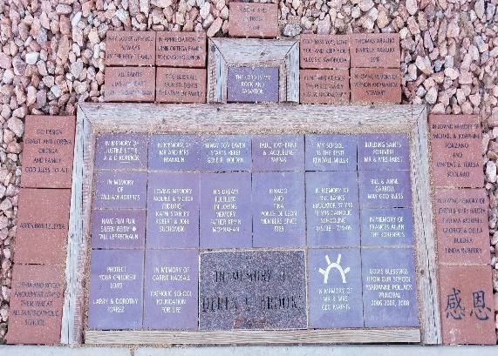
This is a fillable document. Type in all responses. Some fields allow a limited number of characters.
Your first and last name: Click or tap here to enter text.
Address: Click or tap here to enter text. | City: Click or tap here to enter text. | Zip: Click or tap here to enter text.
Email: Click or tap here to enter text. |  | Phone: Click or tap here to enter text.
INCOMPLETE ORDERS WILL NOT BE PROCESSED. PAYMENT MUST BE MADE IN ADVANCE TO ALL SAINTS CATHOLIC SCHOOL VIA CHECK, CASH, OR CREDIT CARD.
PLEASE NOTE THAT SIGNATURES OR ARTWORK ARE $30 EXTRA PER BRICK & CUSTOM LOGOS ARE $85 EXTRA PER BRICK. Include on a separate paper or papers. ASCS and/or Brickmarkers^{R} may edit brick content for appropriateness.
4 X 8 BRICK $140 Maximum of 3 lines, 20 characters per line including spaces
Inscription line 1:
Inscription line 2:
Inscription line 3:

8 X 8 BRICK $190 Maximum of 6 lines, 20 characters per line including spaces
Inscription line 1:
Inscription line 2:
Inscription line 3:
Inscription line 4:
Inscription line 5:
Inscription line 6:

